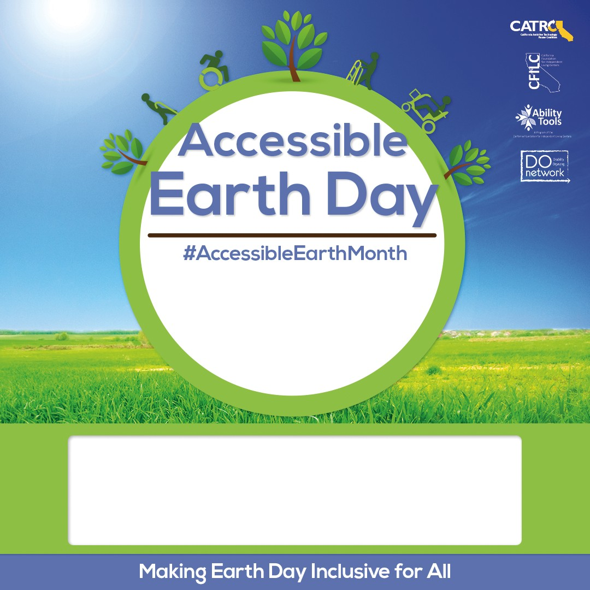

Independent Living Resources Center 1234 Abernathy Street, Suite #100 Santa Barbara, CA 90210 [jane@doe.com](mailto:jane@doe.com) • 559-555-5555